# Context

* Theme: Entertainment
* Persona: Caring Grandmother Anita

## Empathize

Our persona is Grandmother Anita who has a diploma and was recently working. She quit her job, as it was time consuming, so that she can spend more time with her loving and growing family. Her ambitions are to take care of her grandchildren and traveling around the world. She is not comfortable with technology and is not familiar with the industry specific terms. She keeps a scrapbook with all her travels and would like to make more loving memories with her family while traveling. Anita uses social media for sharing her experiences and wants to have a platform where she can share her adventures. Finding ideas for travels is also an interest that she would like to expand and have more options in the future. She is a free and open-minded lady looking for new adventures to fill up her free time.

## Empathy Map

## Moodboard

## Research & Brainstorming Session

Hereby a list of the brainstormed app ideas we’ve made for Anita. Underneath are some worked out concepts that we went through:

**Find a worker app:**

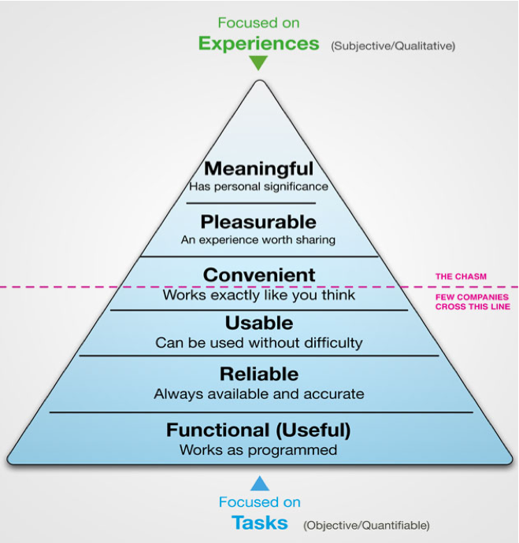 App that shares her photos she has taken while traveling. It sends a notification to the people tagged in the picture she has posted, she can add a location, and only people that are authorized can see her posts. A digital scrapbook that helps here save memories digitally.

People who wish to share their travels and experiences while exploring the world, wish to save their memories but also inform others on how everything is going would be the app’s target market.

They can save their moments they wish to share without being comfortable/understanding of technology.

Competitors:

* Facebook
* Instagram
* TikTok
* Twitter
* VK

1. Sketches
2. Prototype
3. Testing
4. Conclusion